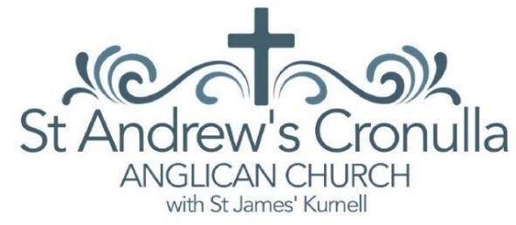Children’s Worker / Children’s and Families Minister – Position Description

Position Title: Children’s Worker / Children’s and Families Minister

Location: St Andrew’s Anglican Church, Cronulla NSW and St James Anglican Church, Kurnell, NSW

Type: Full-Time (negotiable)

Start Date: Immediate (negotiable)

Reports to: Senior Minister

Remuneration: Based on qualifications and experience, in line with Anglican Diocese of Sydney guidelines

# About Us

St Andrew’s Cronulla is an evangelical Anglican church located in the heart of Cronulla, a vibrant beachside suburb in Sydney’s Sutherland Shire that also incorporates a branch church at nearby Kurnell. Our mission is simple but bold: to share the good news of Jesus with our local community. With a long-standing presence in the area and strong ties to local families and schools, we are excited to grow our children’s and family ministry through this new position.

# Position Purpose

We are seeking a passionate, gospel-hearted leader to build and grow our ministry to children and their families. The successful applicant will be committed to evangelism and discipleship, taking existing ministries and expanding them, while also developing new initiatives to reach the next generation with the hope found in Jesus.  
  
This position will suit either:  
- A Children’s Worker with theological training (e.g. Diploma of Theology or equivalent), or  
- A Children’s and Families Minister with a Bachelor of Theology or Bachelor of Divinity

# Key Responsibilities

* Provide leadership and direction for children’s ministries in alignment with the overall vision and mission of the church
* Coordinate and run Sunday kids church during our 10:30am service, ensuring biblical, age-appropriate teaching in a safe and welcoming environment
* Establish and lead a weekly children’s/youth group, building strong relationships with young people and families in the community
* Coordinate SRE (Special Religious Education) in local primary schools, including timetabling, liaising with schools, and recruiting/training volunteers
* Teach SRE in one or more local schools as part of our public witness to Jesus
* Lead and grow our Playgroup ministry, working closely with a volunteer team and connecting with local families
* Facilitate holiday programs with activities and bible-based teaching for local children
* Train and disciple volunteers, building ministry teams and encouraging a culture of prayer, service, and evangelism
* Opportunities to lead services and preach for suitable candidates
* Collaborate with ministry staff, participating in regular team meetings and contributing to the overall vision and strategy of the church
* Work closely with the Churches Safe Ministries Coordinator to ensure all child and youth related activities are conducted according to Safe Ministries Guidelines and all staff are trained and screened according to relevant Sydney Anglican policies

# Selection Criteria

## Essential:

* A clear personal faith in Jesus and a commitment to the authority of Scripture
* A heart for evangelism and discipleship, especially to children and families
* Theological training appropriate to the role:  
   - Children’s Worker: Diploma of Theology or similar  
   - Children’s and Families Pastor: Bachelor of Theology/Bachelor of Divinity
* Experience working with children and/or families in a ministry context
* Strong communication and interpersonal skills
* Ability to lead and inspire volunteers
* Current Working with Children Check (NSW)
* Willingness to comply with Safe Ministry policies and training requirements

## Desirable:

* Experience in SRE teaching and/or coordination
* Experience in planning outreach events or holiday programs

# We Offer:

* A supportive ministry team and church community
* A flexible and collaborative working environment
* Opportunity for professional development and mentoring
* A church demonstrating growth in the area of engaging families with children and having a community impact
* The joy of serving in a beachside suburb with a growing number of young families and children

# To Apply:

Please send your CV, a cover letter addressing the selection criteria, and the names of two referees (including the minister of your current church) to our Senior Minister – Rev’d Greg Ball.  
Email: office@cronullaanglican.org.au by 30th June 2025.

*Early applications are encouraged. Interviews may begin as suitable applications are received and the position may be filled prior to the closing date.*